HtDF Recipe

* Makes easy problems more cumbersome
* But makes hard problems easier

Where is the HtDF recipe?

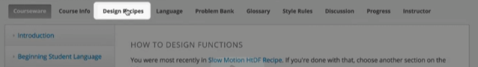

<https://courses.edx.org/courses/course-v1:UBCx+HtC1x+2T2017/77860a93562d40bda45e452ea064998b/#HtDF>

Copy/snip the recipe as an image:

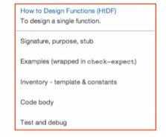

Step 1 – signature, purpose, stub

Signature: 

* Consumes a number and returns a number

Purpose: 

Stub: 

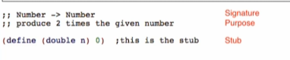

Step 2 – Examples

* Use check-expect for testing



* Run the examples
  + Only to check the syntax and signature violations
  + Check examples are well-formed

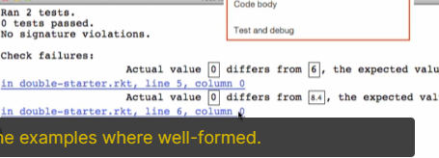

Step 3 – Template & Constants

Template: 

Step 4 – Code Body

Function Body:

* Copy the template first



* Look at everything you did before this step and replace the function body



Step 5 – Test and debug

* Run your program to see if all tests will pass

